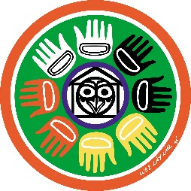
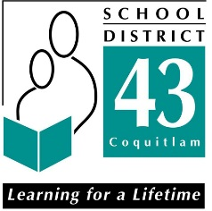
Coquitlam School District 43
Aboriginal Education Department
1432 Brunette Avenue, Coquitlam, BC V3K 1G5
604-945-7386
abedinfo@sd43.bc.ca
Self-Identification of Aboriginal Ancestry
(First Nation, Metis or Inuit)
**Please fill out only if student has Aboriginal Ancestry – one form per child**
Aboriginal Ancestry is determined on a voluntary basis through self-identification. This includes First Nations (status/Non-Status), Metis or Inuit Ancestry. No documentation other than this self-identification is required and the ancestry can go back several generations.
Student Name:________________________________________ Aboriginal Ancestry:________(Yes)
Specify Ancestry if known: ____________________________ (e.g. Coast Salish, Sto:lo, Cree, Metis, Inuit, etc)
School Name: _____________________________________ Grade ______________________________
D. O. B.: _______________________________ (Month/day/year) Gender: _______________________
Home Phone #: ______________________ Cell #: _______________ Email: ______________________________
Siblings: __________________________________ School: ______________ Grade: _________________
(with ancestry)

Parent / Guardian Consultation and Consent to Services
Aboriginal Education Enhanced Support Services
(some services may be limited by site)
□ Academic / Social / Emotional Support □ Cultural Enrichment
□ Home-School communication (letters, phone calls, etc). □ Community Events
□ Monitoring of academic progress and attendance □ Leadership / Conference
□ Graduation/Scholarship/Bursary/Post-Secondary Info □ Breakfast / Lunch Program / Snacks
□ Rites of Passage (transition) □ Field Trips
Comments: _____________________________________________________________________________________

*By signing below I acknowledge that my son/daughter is of Aboriginal Ancestry (First Nations, Metis, Inuit)
*I give consent for my child to access the programs and services available through the Aboriginal Program.
*This signature is considered consent for the duration of the student’s enrollment in their current school.
*Consent can also be given verbally by phone or by email to your Aboriginal Youth Worker. To revoke the consent you must contact the Aboriginal Program office at 604-945-7386 or email abedinfo@sd43.bc.ca.

_________________________________________________________ ____________________________________ (Parent/Guardian Signature or Youth Worker Communication Consult) (Date Signed)

*Please return this form to your child’s school ASAP. If you have any questions, please call 604-945-7386.

